HEART DISEASE PREDICTION MODEL

Project Id: AIML-13

Name : Vanshika Maheshwari (Team Leader)
Class Roll Number:78
University Roll Number : 2028916
Section and Group: G,G2

Name : Priyanshi Tamta
Class Roll Number:55
University Roll Number : 2028809
Section and Group: G,G2

- Problem Description 3
- Architecture 4
- Models model 5
- Evaluation metrics used 7
- Preliminary Results and Visualizations 9
- References 14

1.Problem Description

Design and develop an end-to-end machine learning classification system to predict
heart disease risk using patient clinical health data. The project should include selecting
a suitable heart disease dataset and performing preprocessing steps such as cleaning
missing values, normalization/standardization of medical features, and transformation
of categorical variables (e.g., encoding). Relevant clinical features should be identified
using feature selection methods to enhance interpretability and prediction performance.
The system must include model selection and training using Logistic Regression, KNN,
and SVM classifiers. The trained models must be evaluated using standard performance
metrics such as accuracy, precision, recall, F1-score, confusion matrix, and ROC curve.
The project should demonstrate a complete machine learning pipeline starting from raw
patient records and ending with evaluated predictive models for heart disease
classification.
Expected Output
0 : No Heart Disease
1 : Heart Disease Present

- Architecture
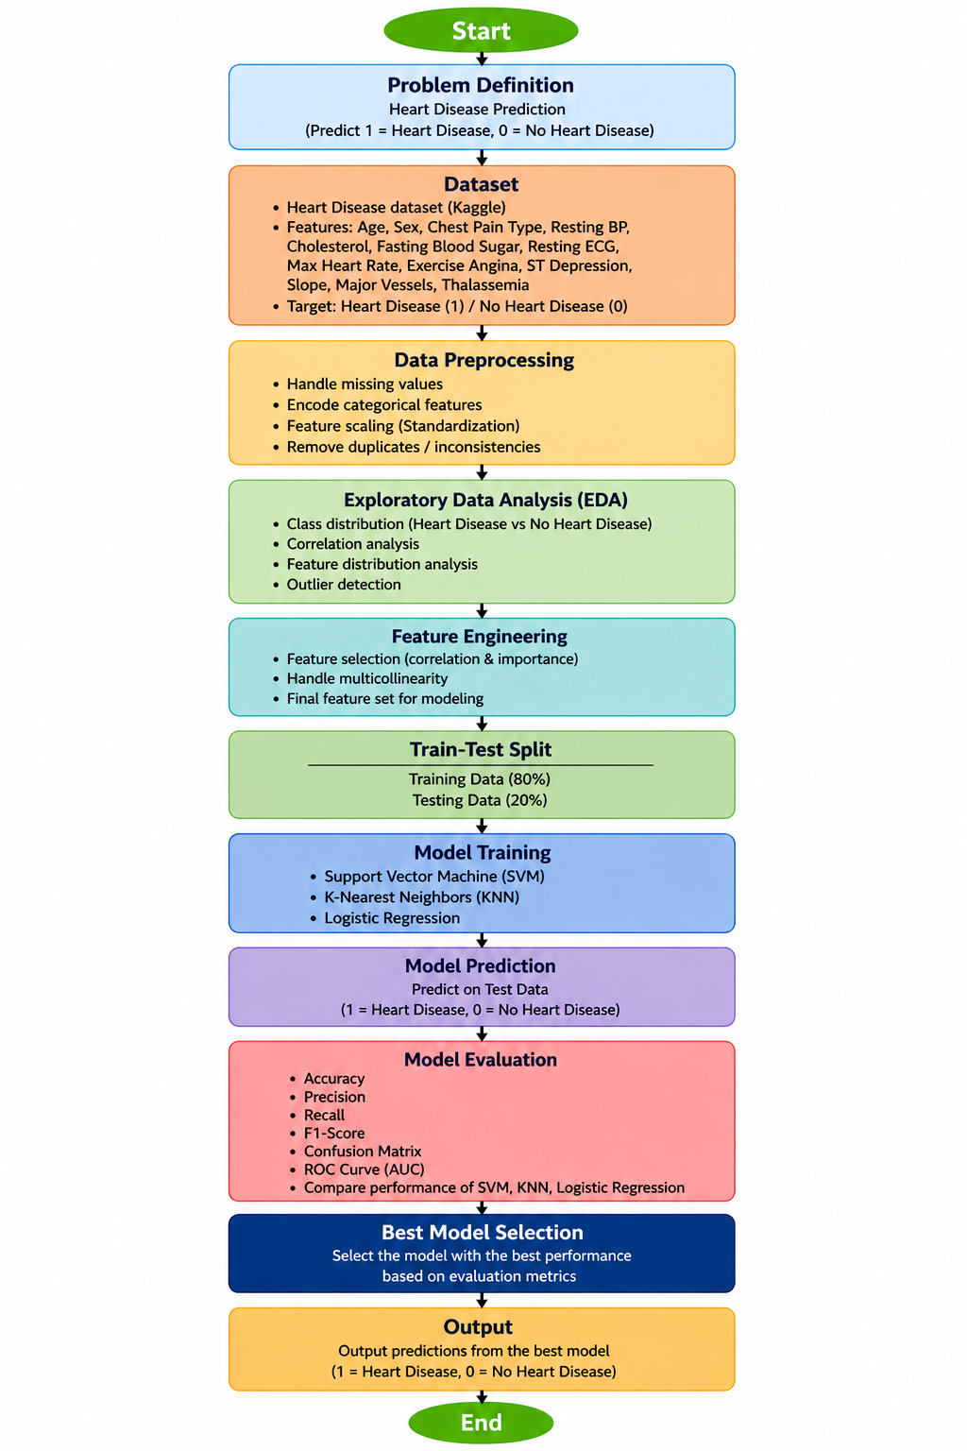

- Models Used(Applied/ Planned) Give a brief introduction of the models used

To develop the heart disease prediction system, three supervised machine learning classification algorithms were implemented and compared: Logistic Regression, K-Nearest Neighbors (KNN), and Support Vector Machine (SVM).These models were selected because they represent different classification approaches and allow comparative evaluation of predictive performance.

1. K-Nearest Neighbors (KNN)
K-Nearest Neighbors (KNN) is a supervised, instance-based classification algorithm that classifies a new data point based on the majority class of its nearest neighbors.
In this project, KNN predicts heart disease presence by analyzing similarity between a patient's clinical attributes and previously observed patient records.
It was selected because:
- It is simple and effective for classification.
- It captures pattern similarity among patient records.
- It performs well when relevant features are selected.
- It provides a non-parametric alternative to Logistic Regression.

2. Support Vector Machine (SVM)
Support Vector Machine (SVM) is a supervised learning algorithm that classifies data by finding the optimal hyperplane separating different classes.
For heart disease prediction, SVM was used to distinguish between patients with and without heart disease based on clinical features.
It was chosen because:
- It performs well in binary classification problems.
- It handles high-dimensional feature spaces effectively.
- It can model complex boundaries between classes.
- It often provides high classification accuracy.
SVM was included to compare a margin-based classifier with other models used in this project.

3. Logistic Regression
Logistic Regression is a supervised machine learning algorithm used for binary classification problems. It predicts the probability of occurrence of one of two outcomes using a logistic (sigmoid) function.
For this project, Logistic Regression was used to classify patients into:
- 0 – No Heart Disease
- 1 – Heart Disease Present
It was chosen because:
- It performs well for binary classification tasks.
- It is simple and computationally efficient.
- It provides interpretable results.
- It serves as a strong baseline model for comparison.
The model learns the relationship between clinical features such as age, blood pressure, cholesterol, and heart disease risk.

- Evaluation metrics used

To evaluate the performance of the implemented classification models—Logistic Regression, K-Nearest Neighbors (KNN), and Support Vector Machine (SVM)—multiple classification evaluation metrics were used. These metrics help assess model effectiveness in predicting heart disease risk accurately.

1.Accuracy

Accuracy measures the proportion of correctly classified instances out of the total observations.
$$Accuracy=\frac{TP+TN}{TP+TN+FP+FN}$$
Where:
- TP = True Positives
- TN = True Negatives
- FP = False Positives
- FN = False Negatives

2.Precision
Precision measures how many positively predicted cases were actually positive.
$$Precision=\frac{TP}{TP+FP}$$
Higher precision reduces false positive predictions.

3.Recall
Recall measures how many actual positive cases were correctly identified.
$$Recall=\frac{TP}{TP+FN}$$
For heart disease prediction, recall is important because missing diseased patients (false negatives) can be critical.

4.F1-Score
F1-score provides a balance between precision and recall.
$$F1=2⋅\frac{Precision⋅Recall}{Precision+Recall}$$
It is especially useful when class distribution may be imbalanced.

5.Confusion Matrix
A confusion matrix was used to visualize classification performance by showing:
- True Positives
- True Negatives
- False Positives
- False Negatives
It helps analyze classification errors made by the models.

6 ROC Curve and AUC Score
Receiver Operating Characteristic (ROC) Curve and Area Under the Curve (AUC) were used to evaluate the performance of the Logistic Regression and Support Vector Machine (SVM) models.
The ROC curve is a graphical evaluation tool that plots:
- True Positive Rate
- False Positive Rate
It helps analyze how well a model distinguishes between patients with and without heart disease across different classification thresholds.
The AUC score provides a quantitative measure of the model’s ability to separate the two classes. A higher AUC indicates better classification performance.
In this project, ROC and AUC were used to:
- Evaluate the diagnostic performance of the models
- Compare Logistic Regression and SVM classifiers
- Measure the models’ capability to distinguish heart disease risk
- Support selection of an effective predictive model
Thus, ROC and AUC analysis helped validate the reliability and effectiveness of the implemented classification models for heart disease prediction
5. Preliminary Results and Visualizations

5.1 KNN- Results and Visualizations

Accuracy: 0.7771739130434783
Precision: 0.8113207547169812
Recall: 0.8037383177570093
F1 Score: 0.8075117370892019
ROC AUC: 0.8390581381235587

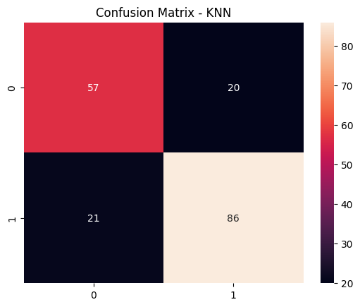

Confusion matrix illustrating the classification performance of the K-Nearest Neighbors (KNN) model for heart disease prediction.

5.2 SVM Results and Visualizations

Accuracy: 0.7934782608695652
Precision: 0.8631578947368421
Recall: 0.7663551401869159
F1 Score: 0.8118811881188119
ROC AUC: 0.837237528826314

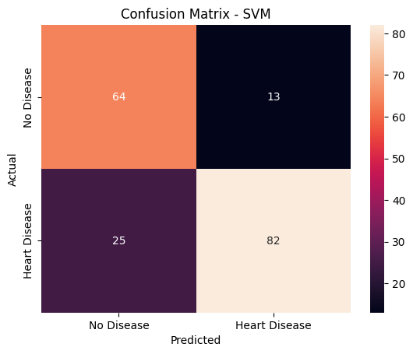

Confusion matrix illustrating the classification performance of the Support Vector Machine (SVM) model for heart disease prediction.

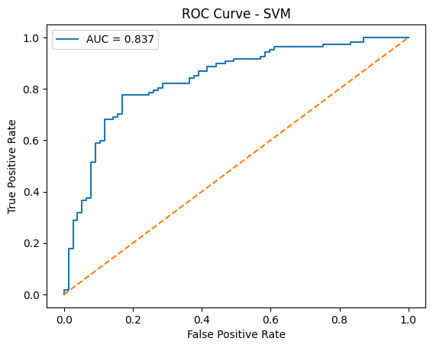

ROC curve illustrating the classification performance of the Support Vector Machine (SVM) model in predicting heart disease risk.

5.3 Logistic Regression Results and Visualizations

Accuracy: 0.8043478260869565
Precision: 0.8736842105263158
Recall: 0.7757009345794392
F1 Score: 0.8217821782178217
ROC AUC: 0.8672168952542784

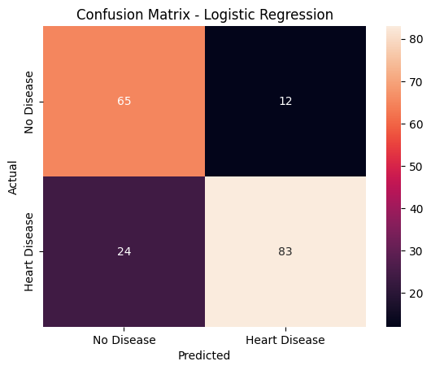

Confusion matrix illustrating the classification performance of the Logistic Regression model for heart disease prediction.

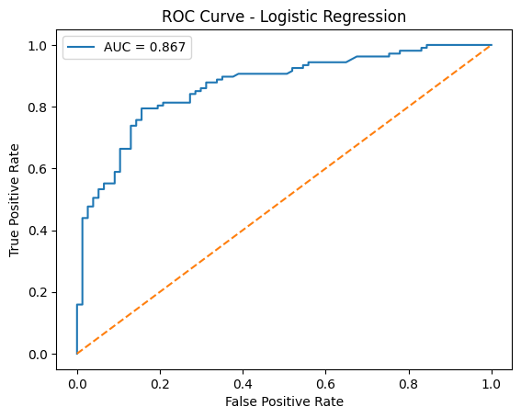

ROC curve illustrating the classification performance of the Logistic Regression model.

6. References:
Books:
- Let Us Python – Yashavant Kanetkar

Online Resources:
  - GeeksforGeeks – https://www.geeksforgeeks.org/
  - TutorialsPoint – https://www.tutorialspoint.com/cprogramming/index.htm
  - Stack Overflow – https://stackoverflow.com

